DBMS LAB 10

Connecting Python Application to MySQL database

By: Ishita Bharadwaj

SRN: PES1UG20CS648

Section: K

Roll No: 43

1. Execute a CRUD (Create, Read, Update and Delete) application in python using Streamlit and MySQL to create a table ‘train’ in the User Interface.

The ‘train’ table should be populated with the following 3 records using the User-Interface

|  |  |  |  |  |  |
| --- | --- | --- | --- | --- | --- |
| **Train_No** | **Name** | **Train_Type** | **Source** | **Destination** | **Availability** |
| 62621 | BEN-CHE Shatabdi | Superfast | Bengaluru | Chennai | yes |
| 62620 | CHE-BEN Shatabdi | Fast | Chennai | Bengaluru | No |
| 25261 | Managaluru Mail | Mail | Chennai | Mangaluru | Yes |

1. Screenshot of database with the table - ‘train’ before populating it.

Command Prompt –

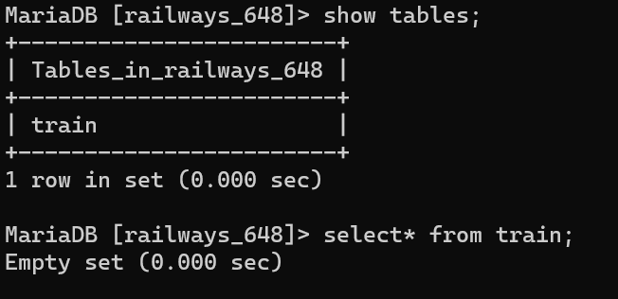

PhpMyadmin –

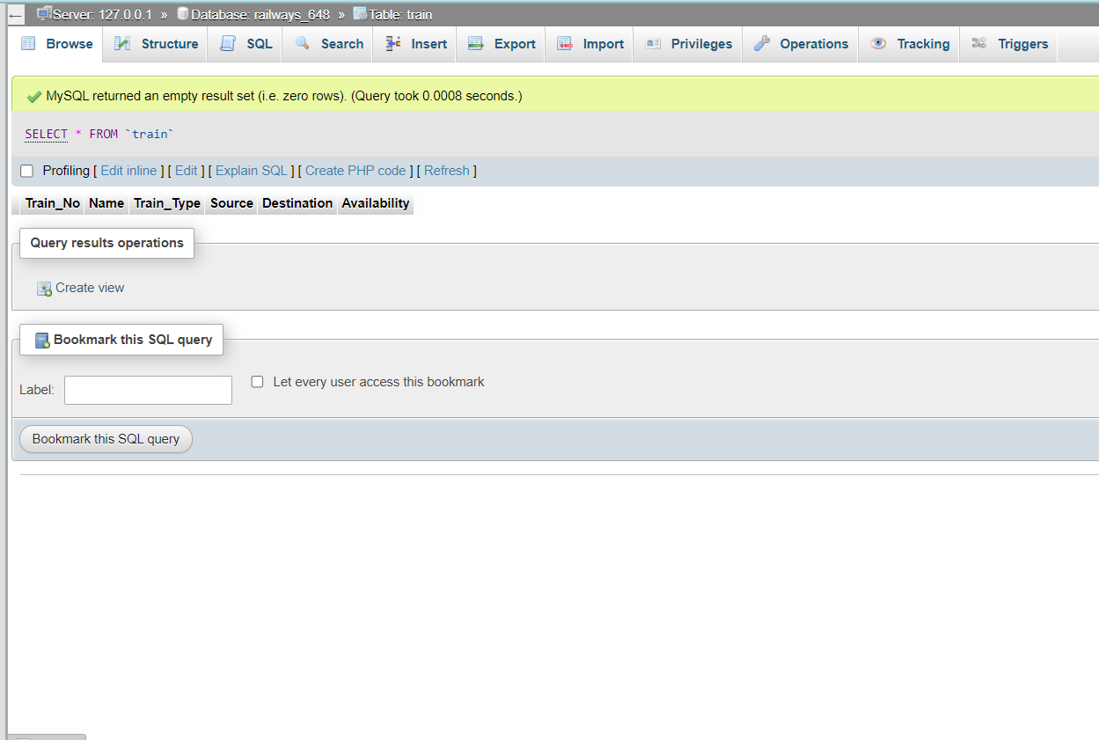

User Interface –

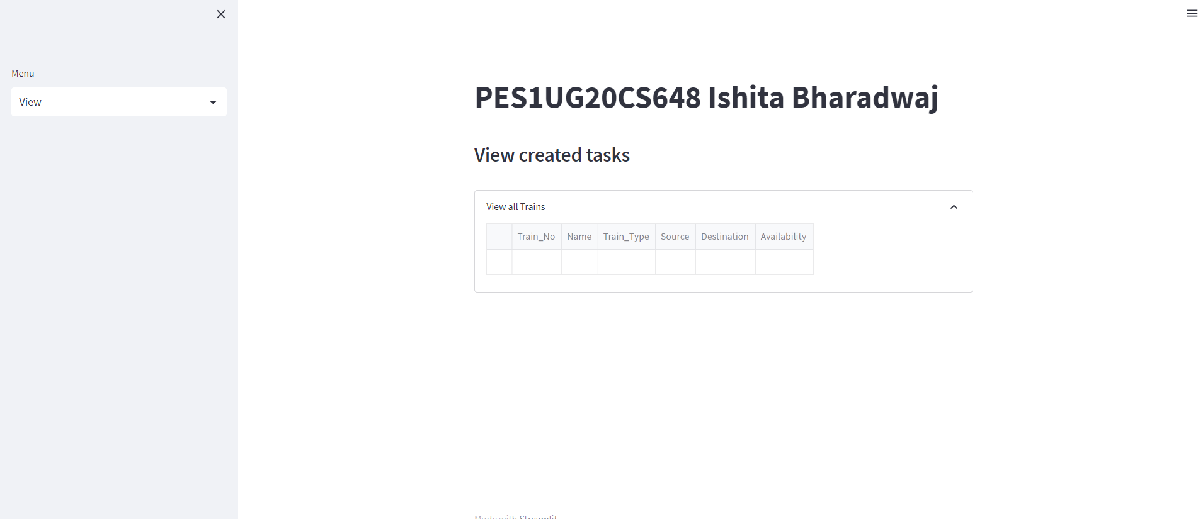

2) Read the details entered at real time in the User-Interface itself.

Inserting 1st row

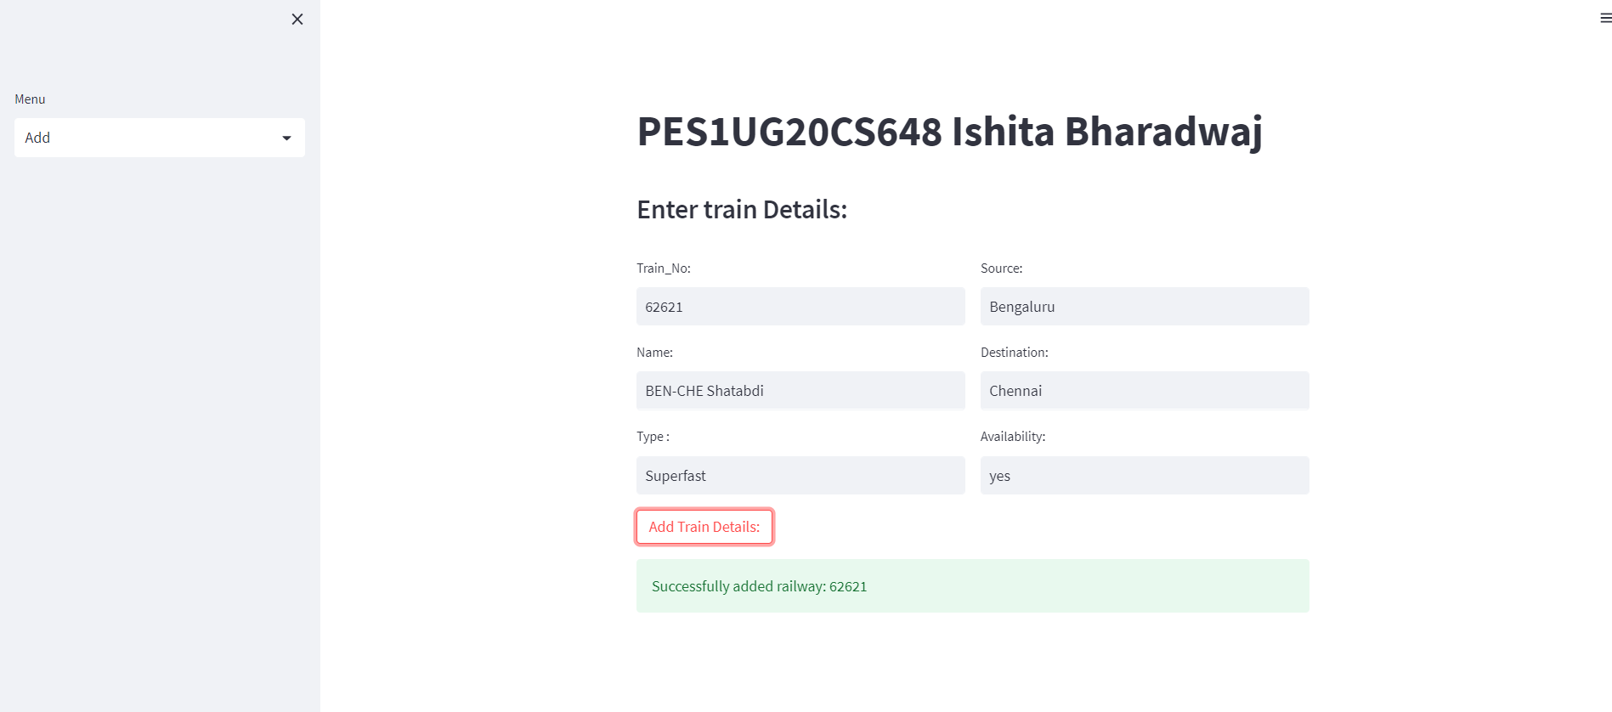

Inserting 2nd row

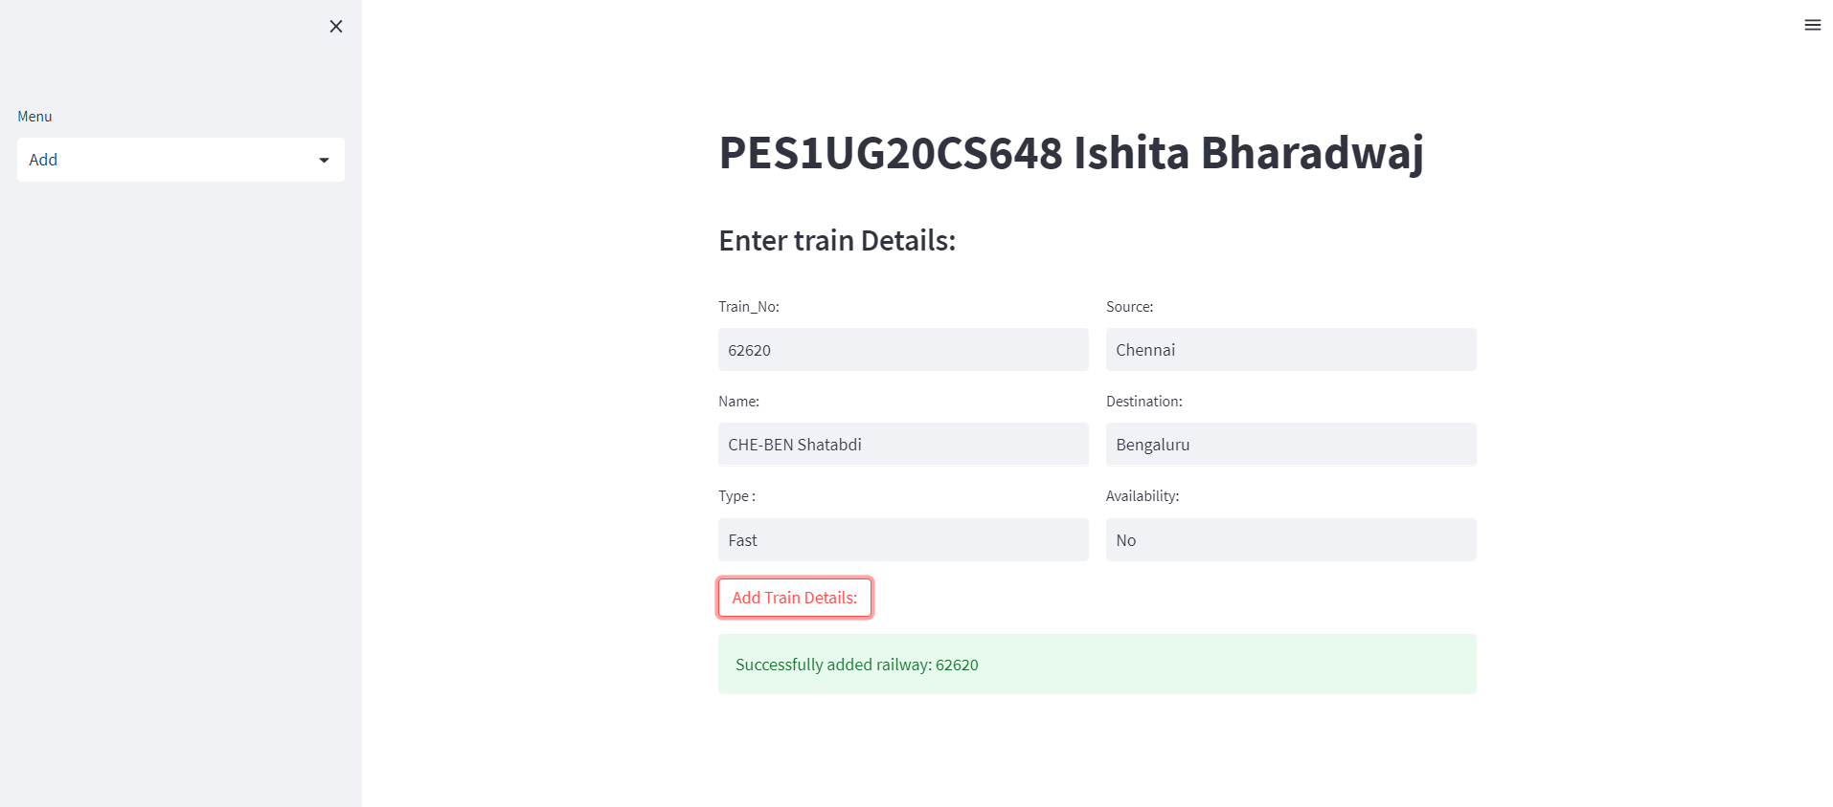

Inserting 3rd row –

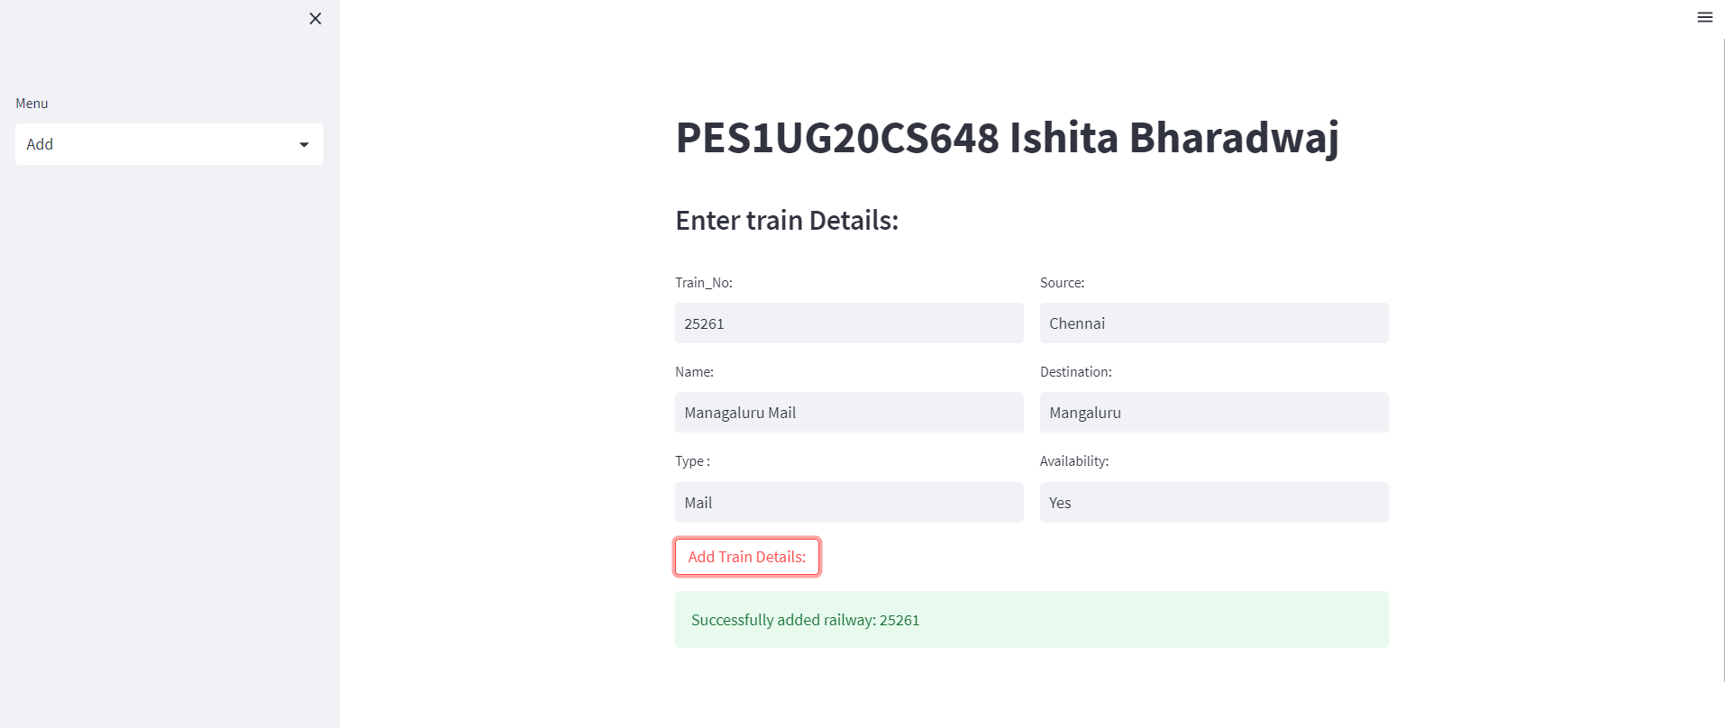

View on user Interface after populating train table–

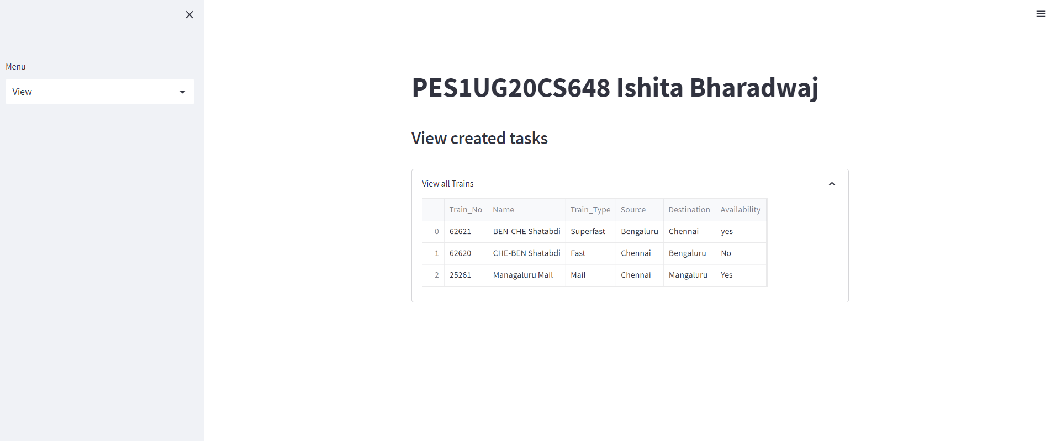

Command prompt –

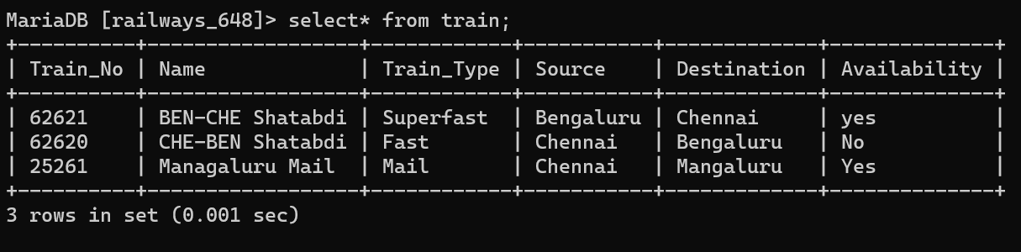

PhpMyAdmin –

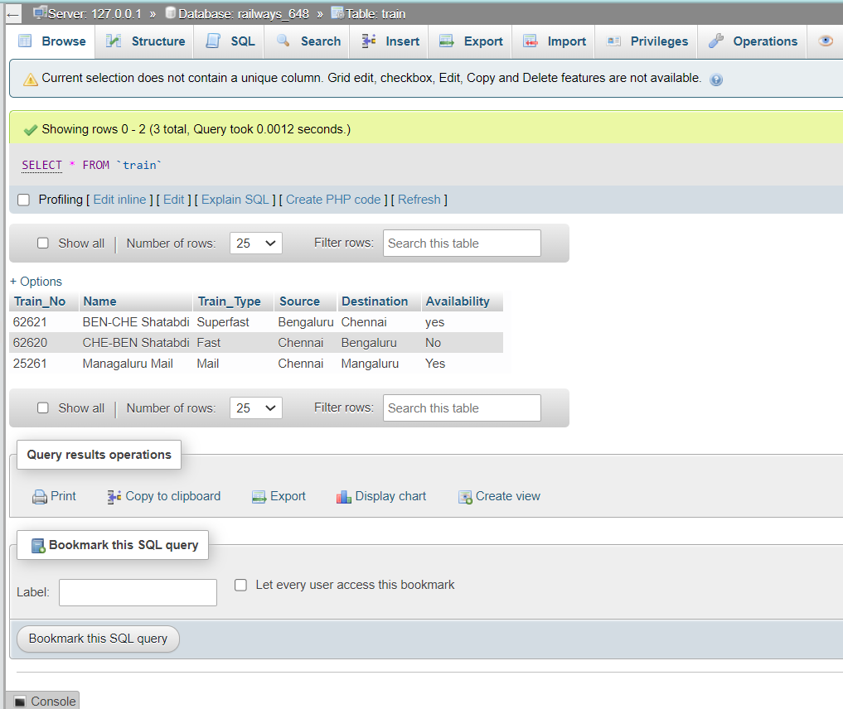

3. Update the ‘Availability’ of the Train_No 62620 to ‘yes’ in the User-Interface.

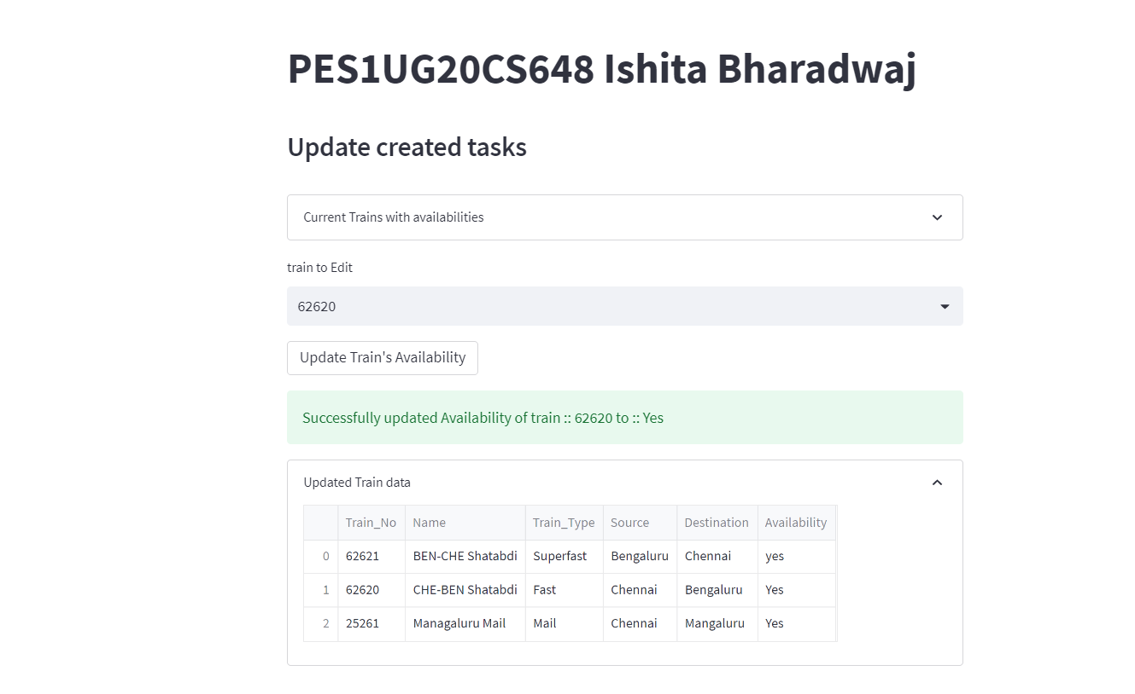

4. Delete the Train_No 25261 in the User-Interface.

Before deletion –

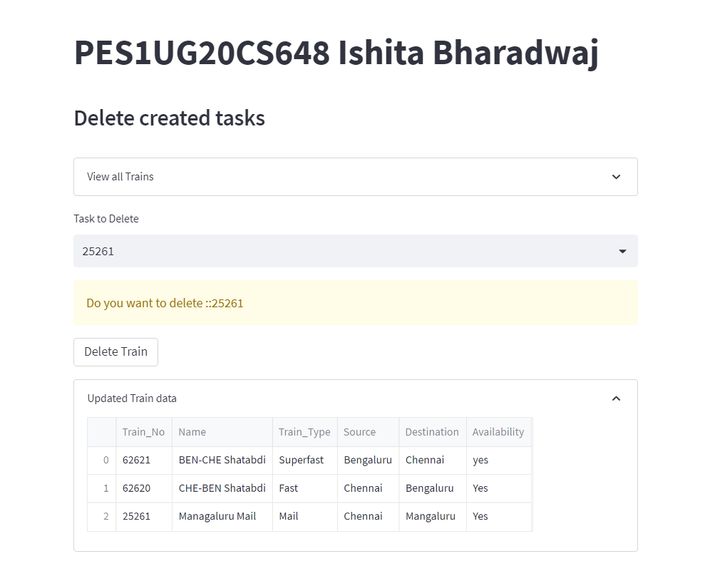

After deletion –

